CONTROL SIGNALS

Introduction to Control Signals

Control signals are crucial in various fields, from electronics to computer architecture, and play a pivotal role in managing and directing the behavior of systems. They are essentially the commands or directives that govern the operation of a system’s components, ensuring coordinated and efficient performance.

Definition and Characteristics

A control signal can be defined as a pulse or frequency of electricity or light that represents a control command as it travels over a network, a computer channel, or wirelessly1. These signals are typically used to convey information between different parts of a system, such as between a processor and memory or between different network devices.

Types of Control Signals

Control signals can be broadly categorized into two types:

Analog Signals: These are continuous and can vary infinitely over time. They are often represented by sine waves and can take any value within a given range.

Digital Signals: These are discrete and take on only specific values, typically represented in binary form as ones and zeros.

Applications in Computer Architecture

In computer architecture, control signals are used to control the hardware components of a computer system. They are essential for the operation of the central processing unit (CPU), where they regulate the flow of data and synchronize the activities of various components.

Control Signals in Data Communication

In data communications, control signals ensure the proper transmission and reception of data packets over networks. They can be embedded within the data packets or sent as separate packets, depending on the protocol used.

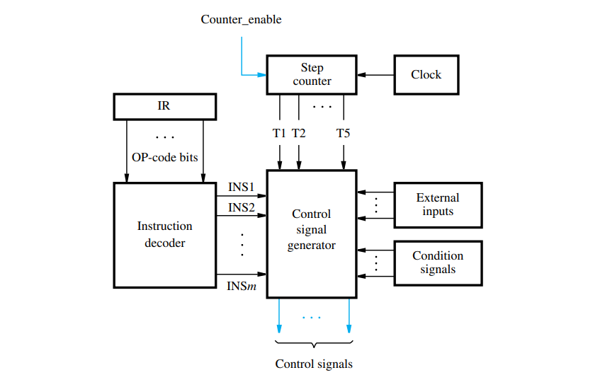

Control Signals in Computer Architecture

In computer systems, control signals are integral to the functioning of the CPU and other hardware components. They are used to coordinate actions and manage the flow of data within the system.

CPU and Control Unit

The CPU contains a Control Unit (CU), which generates control signals to direct the system to perform tasks. These signals are responsible for:

Instruction Fetch: Control signals direct the memory unit to fetch instructions.

Instruction Decode: They help in decoding the fetched instructions to understand the required operation.

Execution: Control signals activate the necessary circuits to carry out the operation.

Buses and Control Lines

Control signals also travel through buses, which are collections of parallel wires that transport data, addresses, and control signals. Control lines specifically carry control signals and are essential for:

Memory Read/Write: Signals like MEMREAD and MEMWRITE control whether data is being read from or written to memory.

Input/Output Operations: Signals such as IOWRITE and IOREAD manage data transfer between the CPU and peripheral devices.

Control Signals in Data Communication

In the realm of data communication, control signals play a pivotal role in managing the transfer of data across networks.

Flow Control

Control signals are used for flow control, ensuring that data is sent at a rate that the receiver can handle. This prevents data loss and ensures efficient communication.

Error Detection

They are also involved in error detection mechanisms. Control signals can indicate when data has been corrupted during transmission, prompting retransmission.

Synchronization

Control signals help in the synchronization of data transmission, ensuring that the sender and receiver are aligned in terms of timing, which is crucial for the integrity of the data.

Advanced Concepts

Digital Signal Processing (DSP)

Control signals are also a part of Digital Signal Processing (DSP), where they are used to manipulate digital signals to improve signal quality or extract information.

Transfer Functions and Operators

In engineering, control signals are often analyzed using transfer functions and operators. These mathematical tools help in understanding the behavior of systems in response to various control signals.

This detailed exploration provides a deeper understanding of control signals, highlighting their critical role in both computer architecture and data communication. For further study, one might consider exploring topics such as signal modulation, coding theory, and network protocols, which offer more advanced insights into the applications of control signals.

Conclusion

Control signals are an integral part of modern technology, enabling the precise control and communication required in complex systems. Their correct implementation and understanding are vital for the development and maintenance of efficient and reliable systems.

This overview provides a comprehensive look at control signals, their types, characteristics, and applications in various technological domains. For a more detailed exploration, including mathematical models and specific examples, further reading and study in specialized texts on signals and systems would be beneficial.